Sales and Revenue Analysis

# Kingsley Agu

# Table of contents

* Executive summary
* Introduction
* Data preparation
* Analysis
* Visualizations
* Insights and recommendations
* Conclusion

# executive summary

This sales and revenue analysis highlights important trends, top performing regions and products, and areas for improvement. Using Excel and SQL, I identified key insights to guide better decision-making.

**Key Insights**

1. **Revenue Trends**:

* Revenue was highest in February at $24,300 but dropped sharply to $16,000 in March, the lowest month.
* April showed slight improvement, with revenue rising to $17,475.

1. **Regional Performance:**

* The West region is the top performer, contributing 28.5% of total revenue, followed by the North at 26.9%.
* The South region is the weakest, with only 20.1% of total revenue, showing room for growth.

1. **Product Performance:**

* Widgets A,D, C and F are the top contributors to revenue.
* Widgets G and H are underperforming and need attention to increase their sales.

1. **Top Products and Regions:**

* Widget A and D bring in the most revenue at $13,250 and $12,375 respectively.
* The West and North regions together account for more than half of the total revenue.

**Recommendations**

1. **Improve South Region Sales**:

* Focus on marketing and sales strategies to boost performance in the South.

1. **Promote Low Performing Products**:

* Increase promotions for Widgets G and H to improve their sales.

1. **Maximize Top Performers:**

* Build on the success of Widget A and D with targeted campaigns and upselling.

1. **Track Revenue Trend:**

* Keep an eye on monthly revenue changes to act quickly on declines and boost growth periods.

# introduction

**Objective of the Project**

The main goal of this project is to analyze sales and revenue data to identify key trends, understand performance by region and product, and provide actionable recommendations for improving overall business growth.

**Tools Used (Excel and SQL)**

To achieve these objectives, I used:

* **Excel** for data cleaning, visualization through charts and Pivot Tables to present insights clearly and effectively.
* **SQL** for data extraction, calculation and analysis of revenue trends, regional performance and product contribution.

# data preparation

**Description of the Dataset**

The dataset contains sales records, including details such as transaction dates, product names, regions and revenue generated. This information is crucial for analyzing trends, identifying top performing products and regions, and understanding the overall business performance.

**Data Cleaning Steps**

The dataset was already complete, with no missing values or duplicates. The main task was to ensure the data types were appropriate for analysis:

1. **Changing Data Types**: Columns such as dates were formatted to “YYYY-MM-DD” for consistency, unit price and total revenue were converted to currency formats.
2. **Standardizing Date Formats**: The date column was modified to display only the month where needed for specific analysis.
3. **Adding New Columns**: Additional columns were created to support specific analysis such as:

* **Month**: Extracted from the date column to analyze revenue trends by month.
* **Percentage Contribution**: Calculated to show how each region or product contributed to the total revenue.

# analysis

**SQL Queries and Explanations**

To perform the analysis, SQL queries were written to extract key metrics and trends. Below are the queries and their explanations:

1. 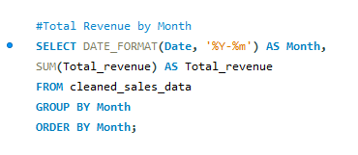**Total Revenue by Month**: This query calculates the total revenue for each month to identify trends over time.

The query groups data by month and sums up the total revenue, allowing us to see revenue trends across the year.

1. **Total Revenue by Region**:

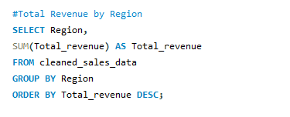This query summarizes revenue contributions by region.

By grouping the data by region and calculating the revenue, we can evaluate the performance of different regions.

1. **Total Revenue by Product**:

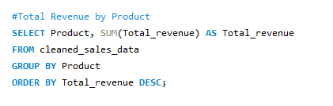This query summarizes the revenue contributions of each product.

The query groups data by product and sums up the total revenue, which enables us to see the revenue contributions of each product.

1. **Top 5 Performing Products:**

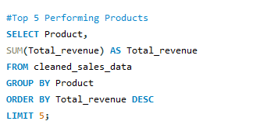This query identifies the top 5 performing products generating the highest revenue.

The query orders the products by revenue in descending order and selects the top 5. This showcases the best-performing products.

1. **Top Performing Regions:**

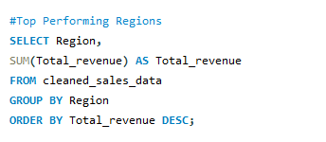This query identifies the top performing regions generating the highest revenue.

The query orders the region by revenue in descending order to showcase the top and underperforming regions.

**Summary Tables and Results**

The results of these queries were compiled into summary tables for analysis:

1. 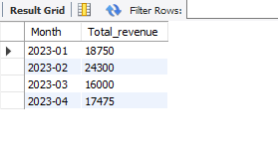**Monthly Revenue Trends**:

Total revenue peaked in February and showed a decline in March, with a slight recovery in April.

1. **Regional Revenue Distribution**:

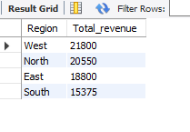The West region leads in revenue contribution, while the South region shows potential for growth.

1. **Top 5 Performing Products**:

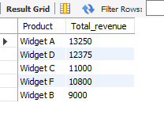Widget A and Widget D are the most significant revenue drivers, indicating where resources should be focused.

# visualizations

In this section, visualizations created in Excel are presented to illustrate key trends and comparisons from the dataset. Screenshots of the charts are included for clarity.

**Total Revenue by Month**

A line chart was created to show the total revenue for each month.

* **Purpose**: To identify trends in revenue over time.
* **Insight**: February recorded the highest revenue, followed by a drop in March and slight recovery in April.
* 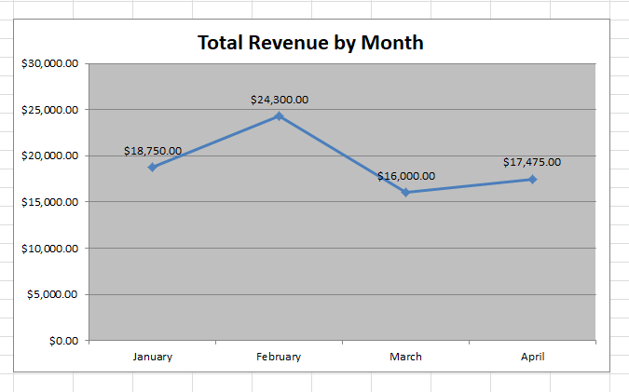**Chart**:

**Top Performing Regions**

A bar chart was used to compare the revenue generated by different regions.

* **Purpose**: To analyze which regions performed best.
* **Insight**: The West region leads, while the South region shows potential for growth.
* **Chart**:

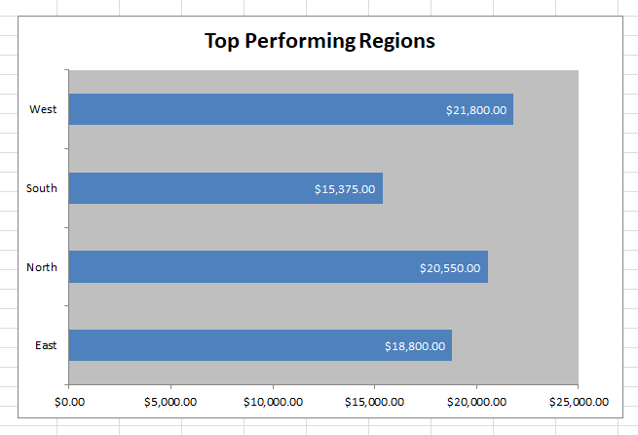

**Total Revenue by Product**

A bar chart displays the total revenue contributed by each product.

* **Purpose**: To evaluate product performance.
* **Insight**: Widgets A, C, D and F perform above average, while G and H underperform.
* **Chart**:

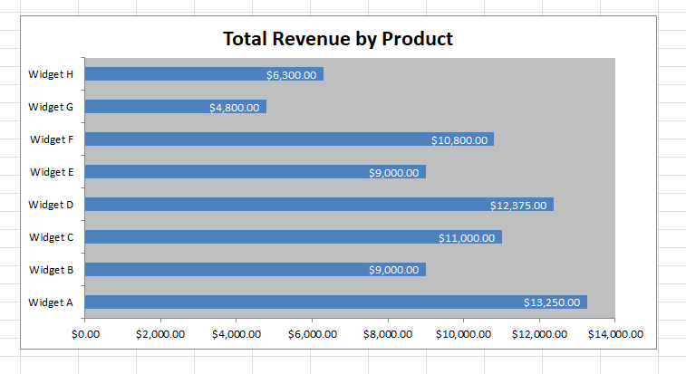

**Top 5 Performing Products**

A horizontal bar chart highlights the top 5 revenue generating products.

* **Purpose**: To identify the key drivers of revenue.
* **Insight**: Widgets A and D are the top performers, followed by C, F and B.
* **Chart**: 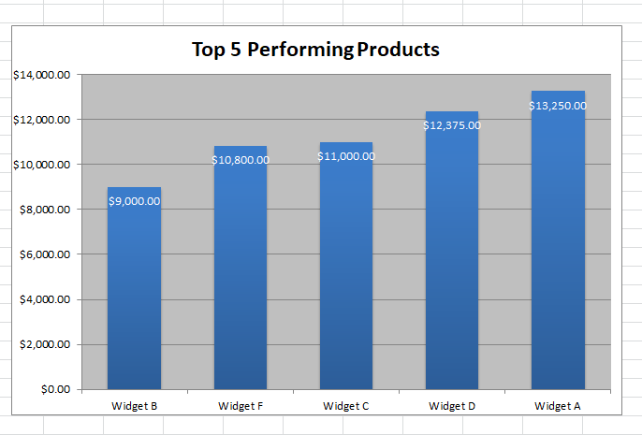

**Regional Revenue Distribution**

A pie chart shows the percentage contribution of each region to the total revenue.

* **Purpose**: To analyze revenue distribution across regions.
* **Insight**: The West region contributes 28.5% of total revenue, while the South region contributes 20.1%.
* **Chart**: 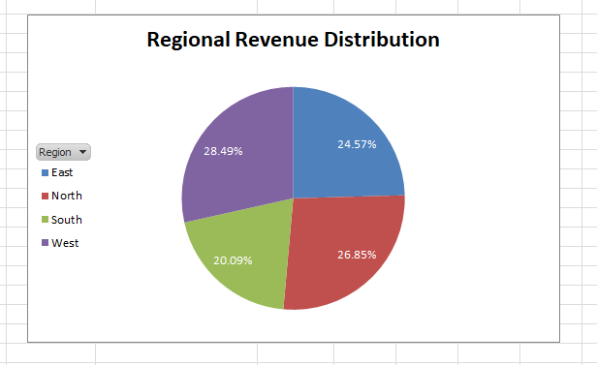

# insights and recommendations

**Total Revenue by Month**

* **Insights**: Revenue was highest in February but dropped a lot in March. There was a small recovery in April, but it hasn’t returned to February levels. Growth hasn’t been steady; February was the only strong month.
* **Recommendations**:
* Find out what worked in February and do more of that (e.g. discounts or ads).
* Look into why March revenue dropped (fewer sales, product issues or external problems).
* Track revenue every month and adjust plans quickly when you notice a drop.

**Total Revenue by Region**

* **Insight**: The West region is bringing in the most revenue (28.5%), with the North close behind (26.9%). The South region is doing the least (20.1%) which means it needs improvement. Revenue is not spread out evenly across the regions.
* **Recommendations**:
* Focus on selling more in the South (find out what customers there want).
* Try out the strategies that worked so well in the West and North in the South region.
* Spend more resources (e.g. staff, ads) in the South to boost sales.
* Create marketing campaigns targeting the South region.

**Total Revenue by Product**

* **Insight**: Widgets A, C, D and F are making the most money which means they’re doing really well. Widgets G and h are doing poorly, way below average. The top products are driving most of the revenue, but the weaker ones need help.
* **Recommendations**:
* Focus on producing and selling Widgets A, C, D and F because they’re in demand.
* Look into why Widgets G and H aren’t selling well (pricing, lack of ads or quality issues).
* Ask customers what they think about the weaker products to figure out how to improve them.

**Top 5 Performing Products**

* **Insight**: Widgets A and D make the most money, leading the top 5 list. Widgets B, C and F are also doing well but there’s room for growth. Widget B is the weakest among the top 5 performers.
* **Recommendations**:
* Keep promoting Widgets A and D to maintain their strong sales.
* Focus on improving sales for Widget b, like better pricing or marketing.
* Make sure top-selling products are always in stock to meet demand.
* Targeted marketing campaigns for Widgets B, C and F so they can perform closer to A and D.

**Top Performing Regions**

* **Insight**: The West and North regions bring in the most of the revenue (over 50% combined). The South region is not doing as well but has room to grow. The West region is the strongest followed closely by the North.
* **Recommendations**:
* Look into why the West and North are doing well and apply those strategies to the South.
* Research the South region to understand why sales are significantly lower.
* Create campaigns for the South to help it catch up with the other regions.

# conclusion

**Recap of the Project**

This project focused on analyzing sales and revenue data to identify trends, high performing products and regions, and areas that need improvement. Using Excel and SQL, I cleaned and analyzed the data, created visualizations, and derived key insights to guide strategic decisions.

**Importance of the Findings**

The findings highlight crucial patterns, such as inconsistent monthly revenue, top performing products and regions, and opportunities to improve underperforming areas. This analysis showcases how data can be leveraged to identify actionable opportunities and improve business outcomes.